Walk 48 Walk along the Border
Last walked in October 2018

Description. 8 km (5 miles). A strenuous ramble up and down a steep hill.
Start. Hay-on-Wye car park. Explorer Map 201. Grid 231423
Directions from Whitecross Roundabout (Turn milometer to zero). Take the A438 towards Brecon, turning L after 12.1 miles. At 19.7 miles TL onto the B4351 to Hay-on-Wye. At the T junction, [21 miles], you TR to Brecon, and at 21.2 miles you TL for the car park which is two hundred yards on your R.

1. Hay Castle. Begin by turning R out of the car park along the road and after 50m TR, at an Offa's Dyke Path (ODP) sign, and walk down a short enclosed track. Go thru a metal gate into a F1 and walk along L edge. Thru k-gate into F2 and walk along R edge. Go thru a k-gate into F3 and straight across the field and along the L edge. Go thru a k-gate into F4 and along L field edge with Dulas Brook below (L). Cross brook via a gated wooden f/bridge and go up an enclosed track. Thru a small metal gate into F5 and up the L edge. Thru small metal gate, and continue in the same direction along ODP, to go out into F6. Cross the field and over a stile/metal gate into F7 to cross a track, bear slightly L and head for a t/pole.

2. T/pole. On reaching the L field corner by a gate and the ODP signpost, you TR, (do not go thru the gate). Continue up the L field edge to reach a road via a stile. TL along road for 100m. TR to cross a stile into F8 and carry straight on up the R field edge, (a brook is on the R). After 300m you TR to cross over the brook via a wooden f/bridge, thru a k-gate and into F9. TL immediately and walk up L field edge. Cross a stile and wooden f/bridge and up an enclosed aggregate track to go thru a small metal gate onto a road.

3. Danyforest Farm. TR, walk along the road between buildings and then quite steeply up. Just before a cattle grid you TR and cross over a stile. Go down the L side of the tree clearing to go thru metal gate into F10. Keep to L edge of steeply sloping field, and after 75m, TL over a stile. Cross a stream in a minor ravine and go up and over another stile into F11. Bear slightly R as you go down this field. Cross a ditch and stile into F12. Cross this field, heading for the L of a farmhouse, and go thru a gate and across a stream, (a few paces further on you can reach a low marker post). TR and go thru gate, thru a farmyard and a gate and onto a lane.

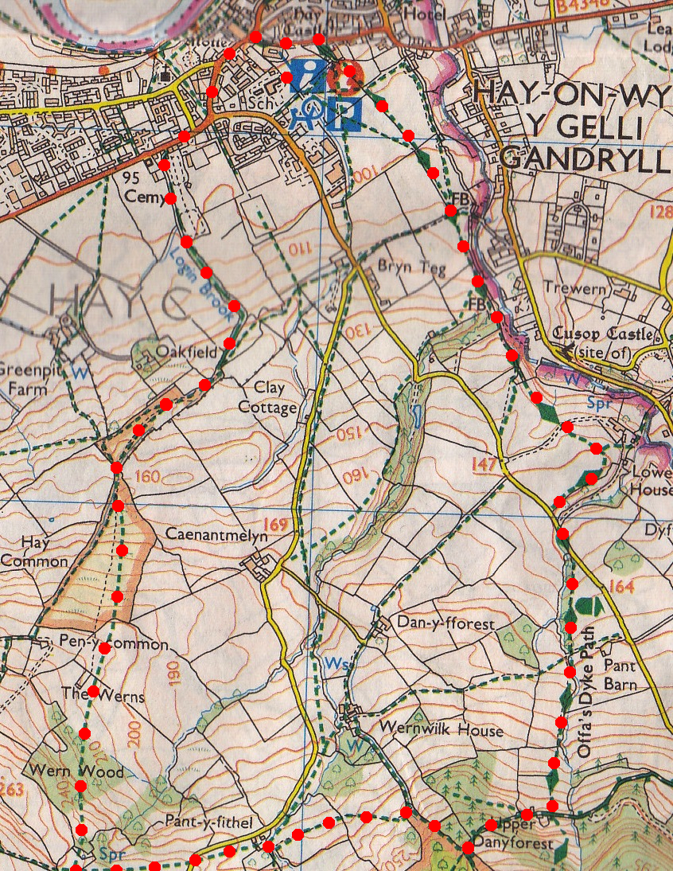
4. Pant-y-fithel. TL, walk along the lane to reach the first bend. TR over a ditch and stile into F13. Cross the field and head for the gate on the skyline. Go thru gate and TR, walk along the R field edge/fence and cross the stile ahead. Go thru three strips of woodland, passing a marker post (R) at the start of the third strip. Leave the woods thru a gap and head to the R of a farm house (The Werns) to cross a stile/metal gate into F14. Go slightly L thru this field to cross a stile, a minor road, and another stile into F15. Go slightly R as you keep ahead down thru a scrubby field, which tapers thru trees. Beyond a gap, follow the hedge (L) down track thru copse. Now TR along R edge/hedge. A little further on (R) is a small white post with Mainline Pipelines Ltd., written on it.
5
1
2
5. White post. Mainline Pipelines Ltd. With railings over to the R, keep ahead to reach Login Brook. Go thru the lower gate (L), which is a small metal gate, and over a f/bridge. Now follow the brook, crossing it twice, below Hay cemetery to reach a road beyond lych-gate. TR, go past Recreation Ground to Hay Castle.
4
3
4
3

